**Extro Curve Spout Single Lever Sink Mixer – White Handle**

**Product Description:**  
A sleek and modern single lever sink mixer featuring a tall curved spout and ergonomic white lever handle. Ideal for contemporary kitchens and utility spaces.

**Key Features :**  
✅ Tall curved spout for wide sink coverage  
✅ Single lever for easy temperature and flow control  
✅ Smooth chrome finish with white handle accent  
✅ Brass body for durability and corrosion resistance  
✅ Easy deck-mounted installation

**Product Specifications:**  
• Brand: Extro  
• Product Type: Sink Mixer  
• Material: Brass  
• Finish: Chrome  
• Handle Type: Single lever (white finish)  
• Mount Type: Deck mounted  
• Warranty: 5 years

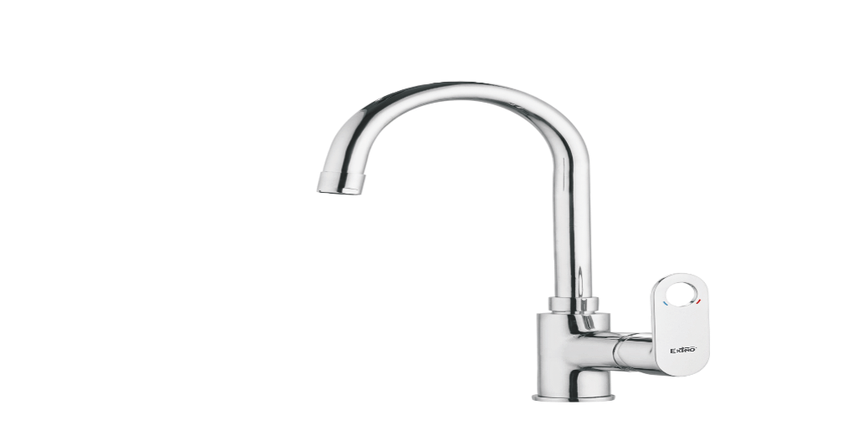

**Extro Curve Spout Single Lever Sink Mixer – Chrome Handle**

**Product Description:**  
An elegant chrome-finished sink mixer with a high-arch spout and a smooth single lever for precise water control, crafted for modern kitchens.

**Key Features :**  
✅ Ergonomic lever for one-touch operation  
✅ Curved spout for splash-free performance  
✅ Sleek chrome handle with brand engraving  
✅ Corrosion-resistant and long-lasting build  
✅ Compatible with hot and cold inlet systems

**Product Specifications:**  
• Brand: Extro  
• Product Type: Sink Mixer  
• Material: Brass  
• Finish: Full Chrome  
• Handle Type: Single lever (chrome finish)  
• Mount Type: Deck mounted  
• Warranty: 5 year

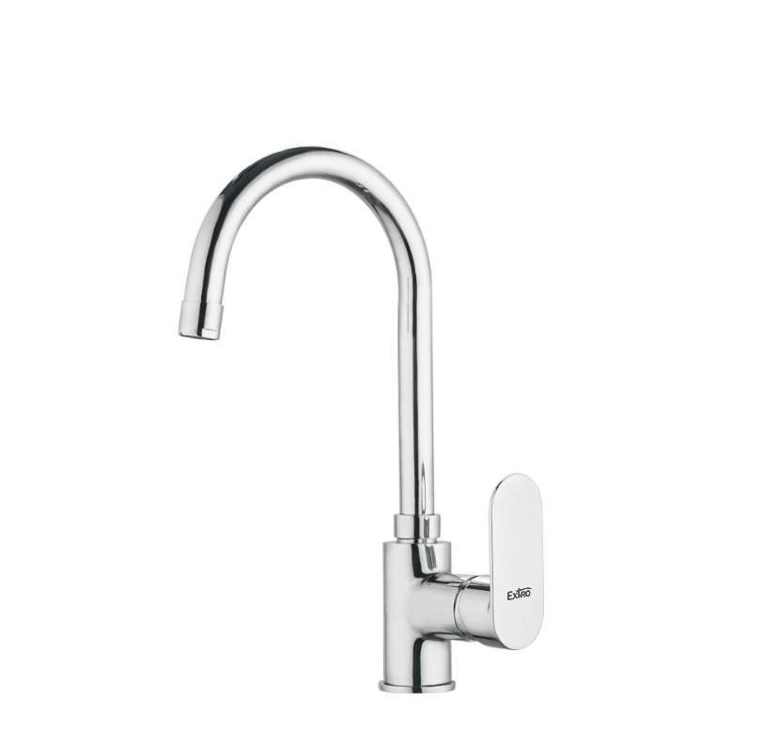

**Extro Square Neck Single Lever Sink Mixer – Flat Handle**

**Product Description:**  
A contemporary sink mixer with a square-neck spout and flat lever handle, designed to bring geometric elegance and utility to premium kitchens.

**Key Features :**  
✅ Angular design for bold aesthetics  
✅ Square spout for concentrated flow  
✅ Flat lever for smooth single-hand use  
✅ Heavy-duty brass with polished chrome coat  
✅ Suitable for hot and cold water supply

**Product Specifications:**  
• Brand: Extro  
• Product Type: Sink Mixer  
• Material: Brass  
• Finish: Chrome  
• Handle Type: Single lever (flat square design)  
• Mount Type: Deck mounted  
• Warranty: 5 years

